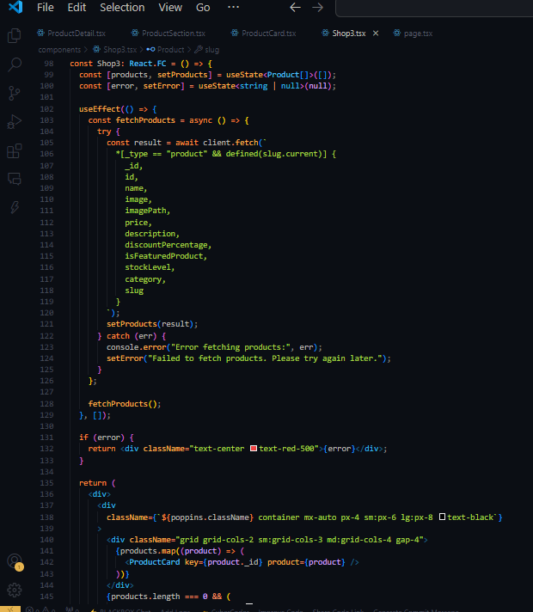  
**Product Fetch from Sanity**

**Dynamic Route   
Product Detail Page**

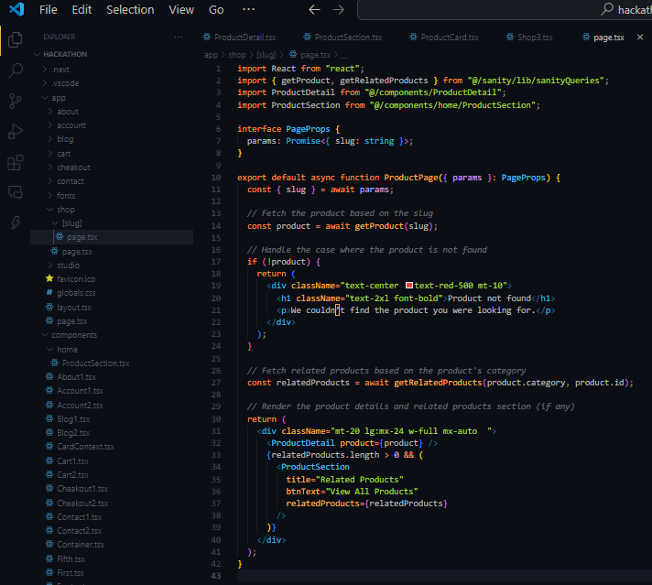

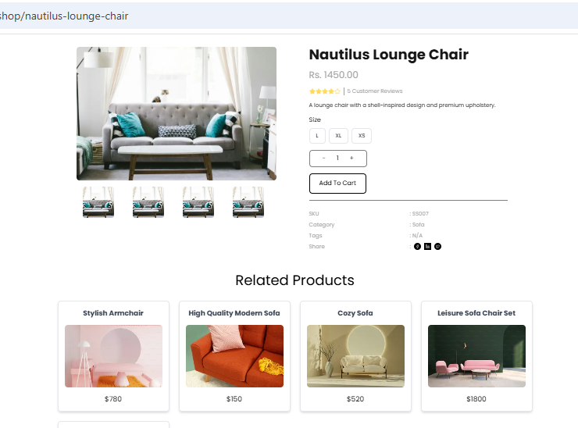

**ADD TO CART :**

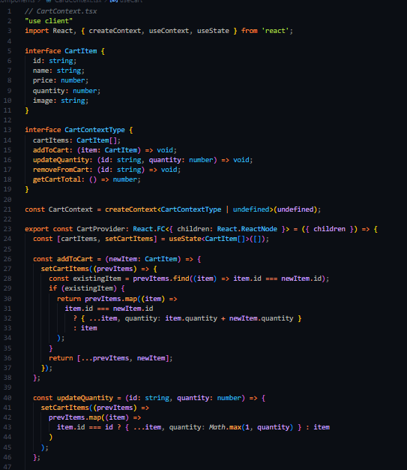

**Github Link :** [**https://github.com/Muhammad-Saad-Awan/hackathon**](https://github.com/Muhammad-Saad-Awan/hackathon)

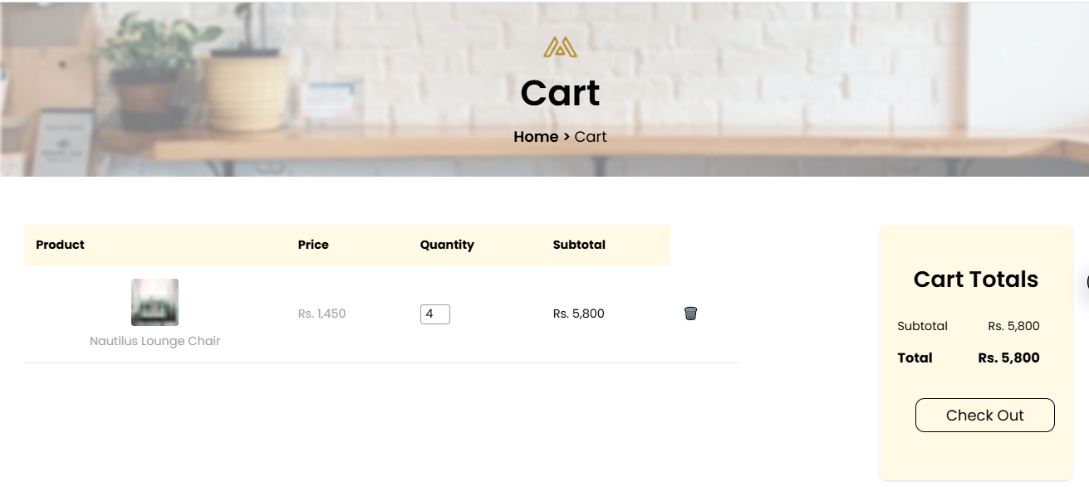

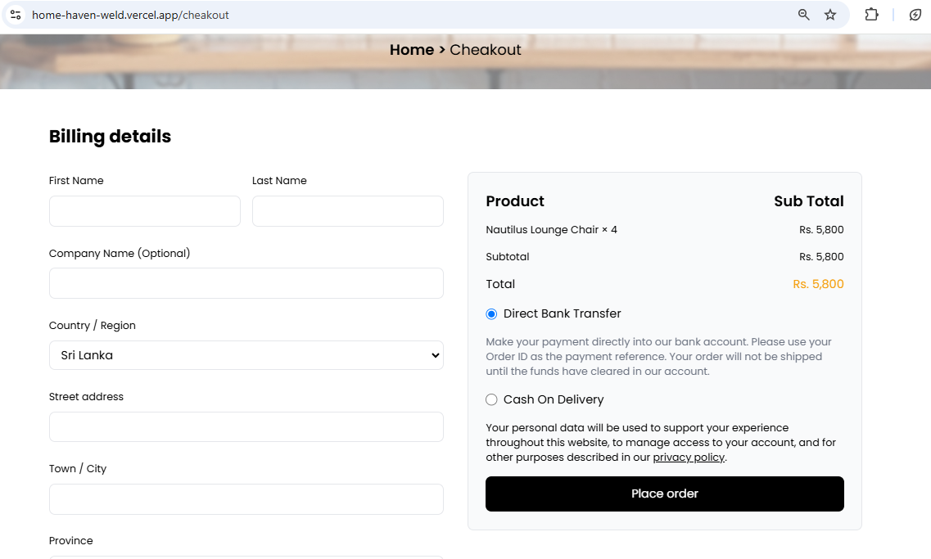**Cheakout**